Create

1. Development Progress Log

Week 1 (December 2024)

- 2/12/2024/ The First Day, introduction to the project brief, idea generation, and brainstorming
After an initial search, I chose Housing as my investigation topic.
By using Google Advance Search, I found a publicly available dataset called “The Housing Agency”,
it became the starting point for my research

Week 2 (January 2025)

- 8/1/2025/ Investigation 1st draft, didn’t include a discussion of two alternative project ideas that were considered but rejected and a Identification of potential stakeholders and end-users.
- 9/1/2025/ Investigation 2nd draft, missing parts were added however exceeded. However, I failed to adhere 400 words requirement.
- 9/13/2025/ Investigation 3rd draft, words count under the limit and all essential parts included after adjustment.

Week 3 (January 2025)

- 15/1/2025/ Plan and Design 1st draft
- 21/1/2025/ I create the wireframe for my system with the tool “Whimsical”
- 26/1/2025/ I create the flowchart for my system with the tool “drawit.io”

Week 4 (January 2025)

- 27/1/2025/ Plan and Design 2nd draft, fixed some typos and added wireframe and flowchart to the document.
- 30/1/2025/ Plan and Design 3rd draft, add flowcharts for python data extracting sorting visualization.

Week 5 (February 2025)

- 5/2/2025/ Create stage started, coding coding coding ………
- 6/2/2025/ Data downloaded from different public datasets.
- 8/2/2025/ Cleaned CSV files made, all information cleaned and sorted using Python
- 9/2/2025/ Frame of the website made, adjust background color and CSS

Week 6 (February 2025)

- 10/2/2025/ I was filling information into my interactive information system, adding SVG graphs, a Recommendation tool, and test the Firebase functionality. However, the installation of the Pygal module failed, so the graphs weren’t interactable at the beginning with several other problems encountered. I had been overly optimistic about my coding skills, so I decided to iterate back to the previous section of the create stage to make the code more concise.
- 12/2/2025/ Start testing process, functional and unit testing.
- 13/2/2025/ Unit test complete, test table created.
- 16/2/2025/ Functional test complete, test table created. Final refine and optimize the overall visual layout of the webpage.

Week 7 (February 2025)

- 17/2/2025/ Write pseudocode for algorithms.
- 23/2/2025/ Evaluation Stage Started

Week 8 (February 2025)

- 24/2/2025/ Create 2nd draft, adjust contents to suit the marking scheme requirements. Evaluate in general rather than break into different parts.
- 25/2/2025/ Evaluation 1st Draft completed, exceeded 300 words limit.
- 27/2/2025/ Review Evaluation 2nd Draft. Adding more comments on the source documentation for any modules or coding methods I used.

2. Problems Encountered

- Pygal is the visualization tool for my project, and it’s an external tool package that is not embedded in the Thonny IDE. Initially, I attempted to download it within the IDE, but I found it missing from the package library. To resolve this, I search online using resources like YouTube and Google, and found that I need to input the pip install Pygal command into the CMD console on my device, not directly into the Thonny shell. This solution solved my issue and made my graphs interactable.
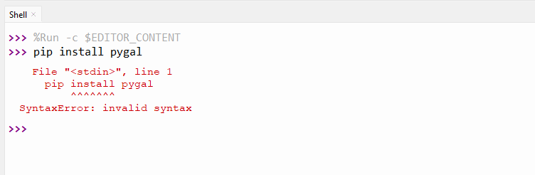

- When visualizing Housing Cost Overburden data into a bar chart, my initial idea was to use For Loops and Panda to extract Housing Cost Overburden data for six years from a large CSV file and visualize it to a single graph. However, the coding skills required were beyond my current abilities and understanding. Instead, I applied one of the computational thinking techniques --- Decomposition, which involves breaking problems down into smaller components so they can be tackled easier. In my project, the code became much more concise and easier to understand by dividing the large graph into six smaller graphs, each representing the data for a specific year. I was able to locate the relevant data for each year by using the row position and index in the CSV file, as the data was organized to repeat every four rows.
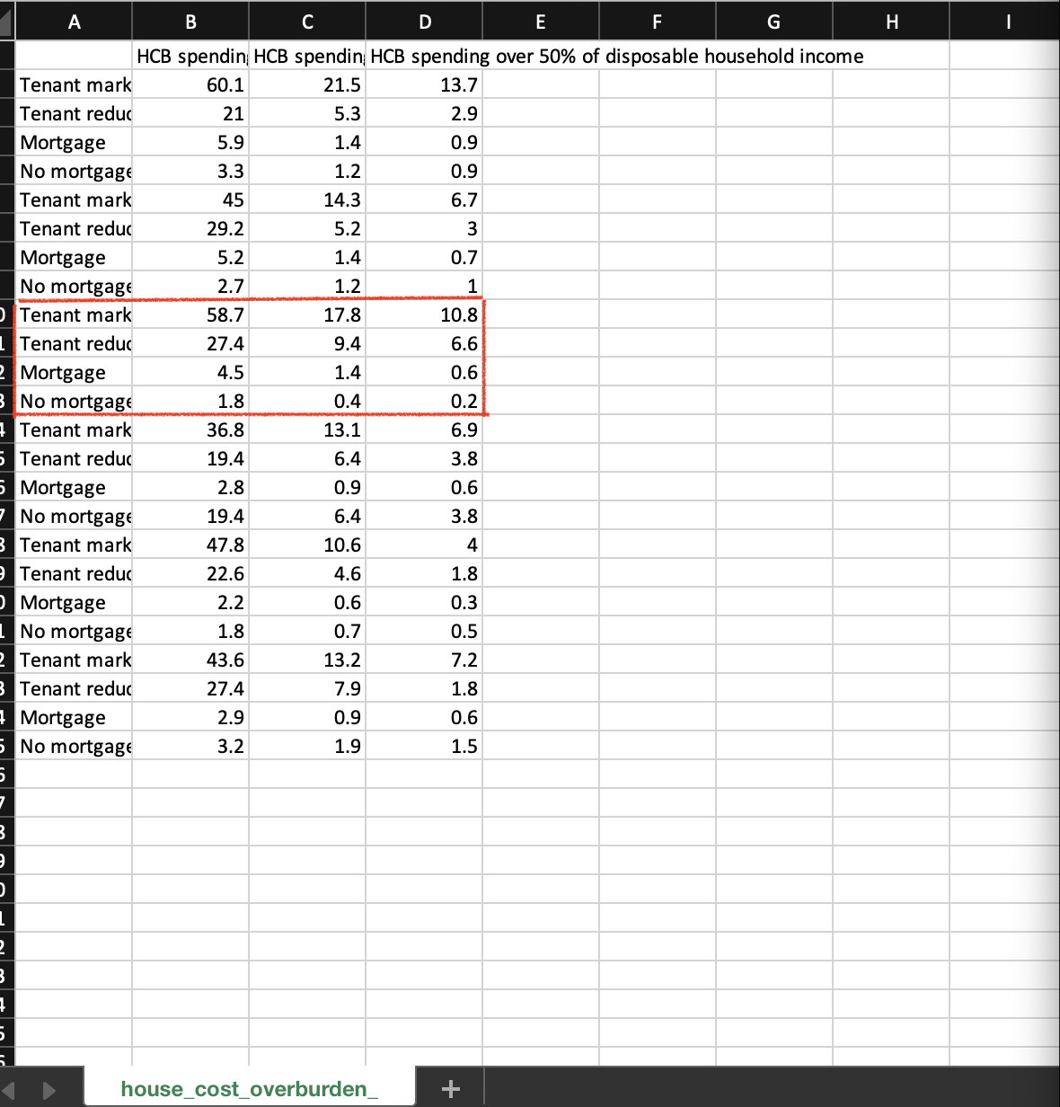
(Before) For example, HCB data for 2019 is stored together within a large csv file containing data from 2017 to 2022, it was difficult to visualize them together in a bar chart.

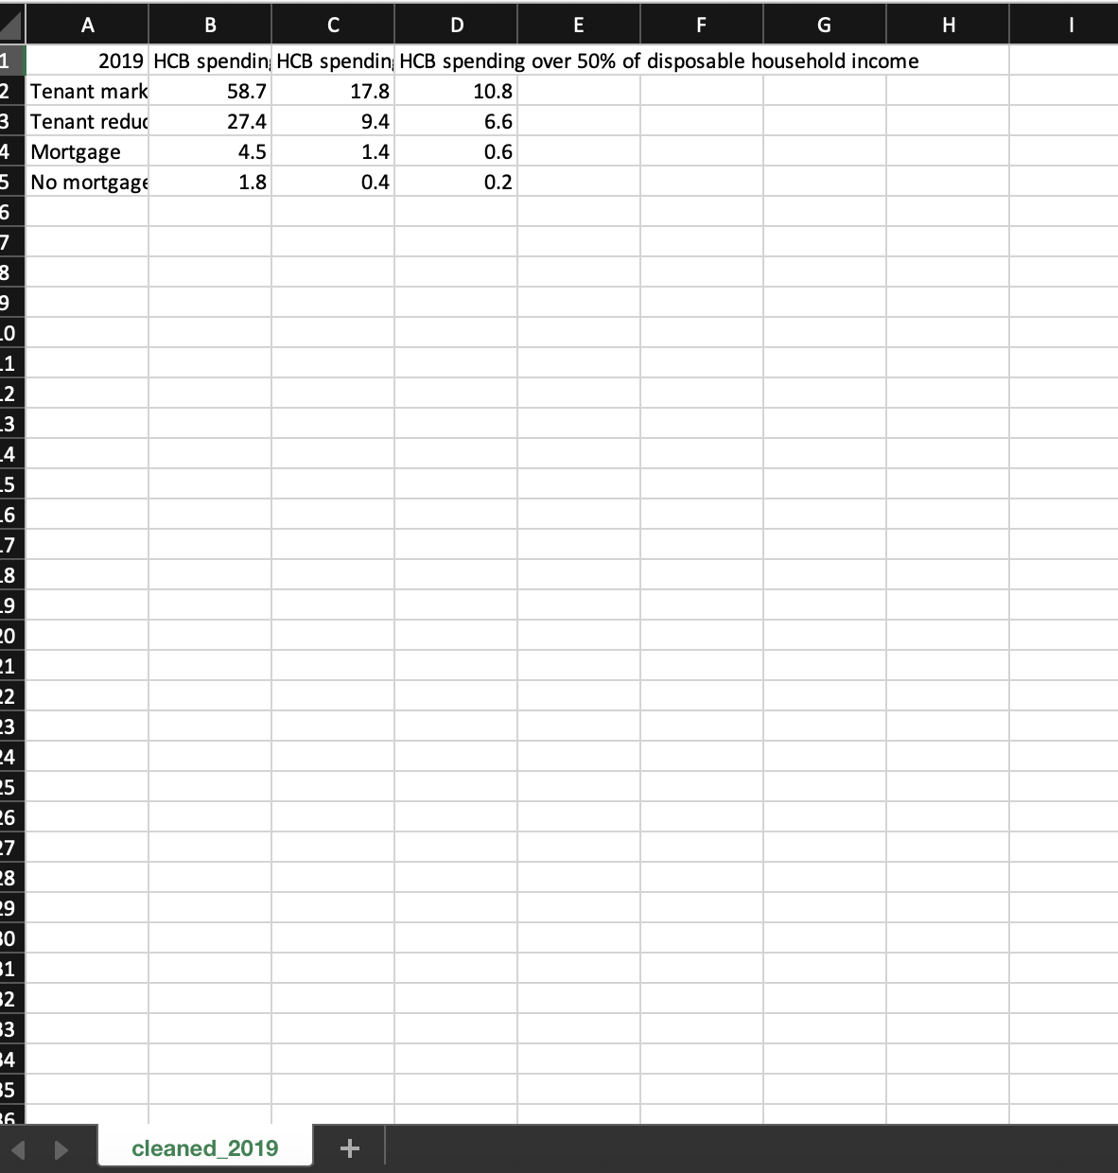
(After) HCB data for 2019 is isolated for further visualization to a bar chart containing data only for that year.

3. Program Testing

Unit Testing

Objective: helps to eliminate the risk of having bugs in code by break the software code to each unit, validate each unit and check whether they are performing as expected.

Webpage Display Test

- showHousePrices() function

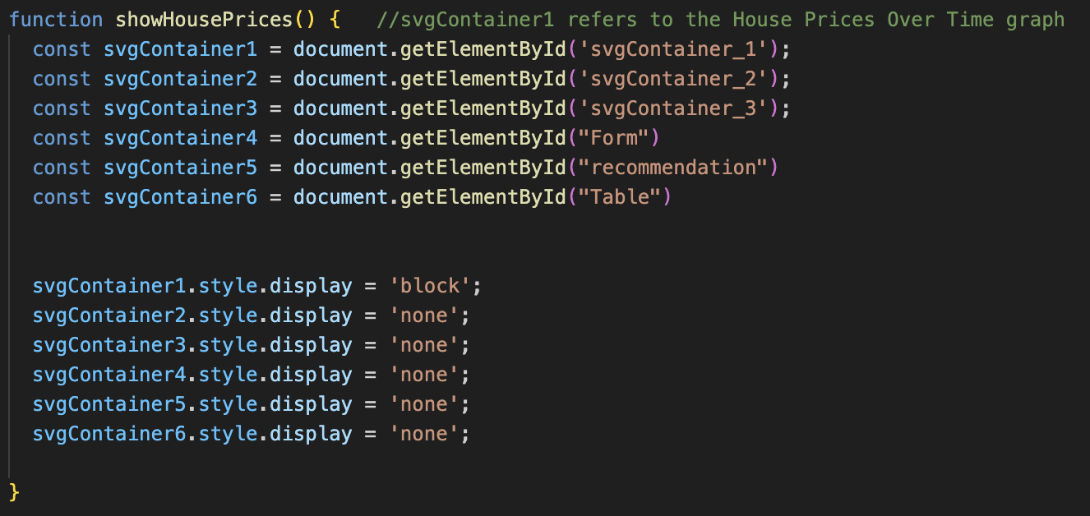

Verify that svgContainer_1 is displayed while others are hidden.

- showHCB() function

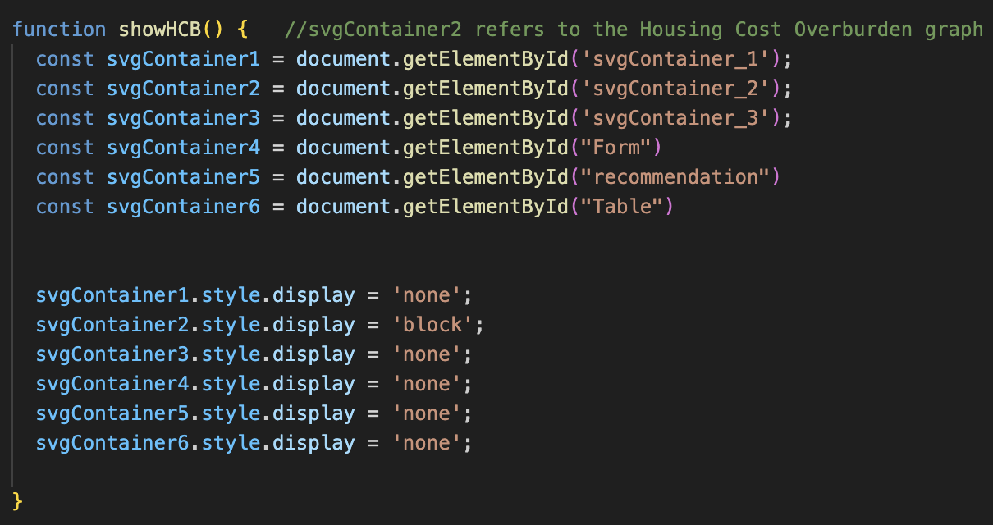

Verify that svgContainer_2 is displayed while others are hidden.

- showAverageRent() function.

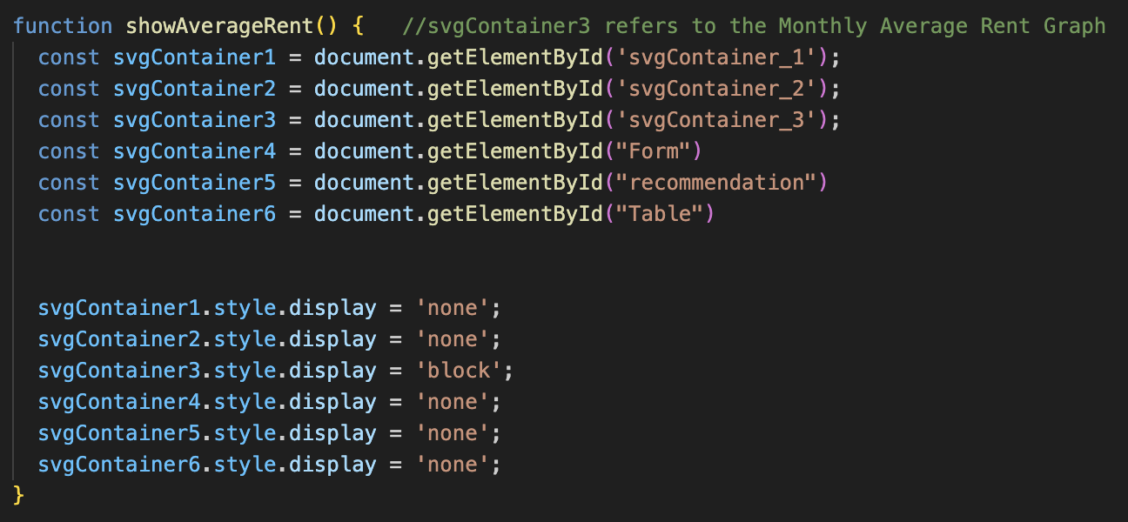

Verify that svgContainer_3 is displayed while others are hidden.

- showForm() function

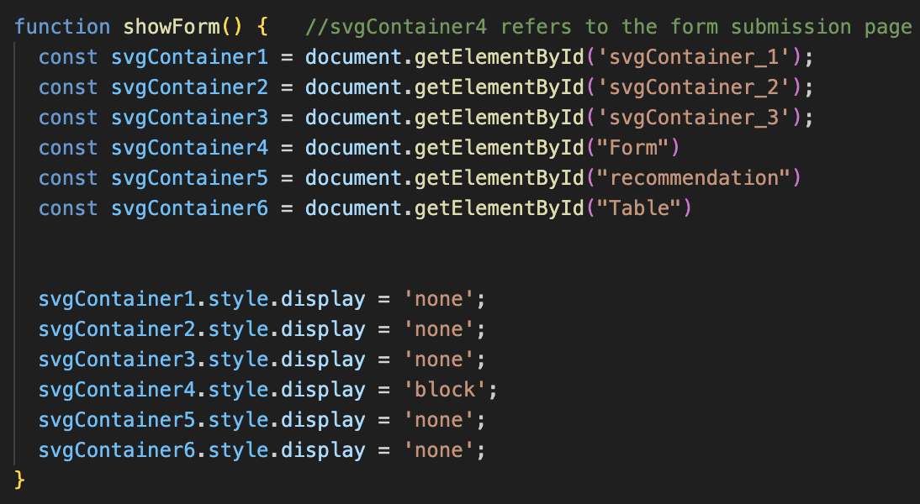

Verify that svgContainer_4 is displayed while others are hidden.

- showRec() (recommendation) function

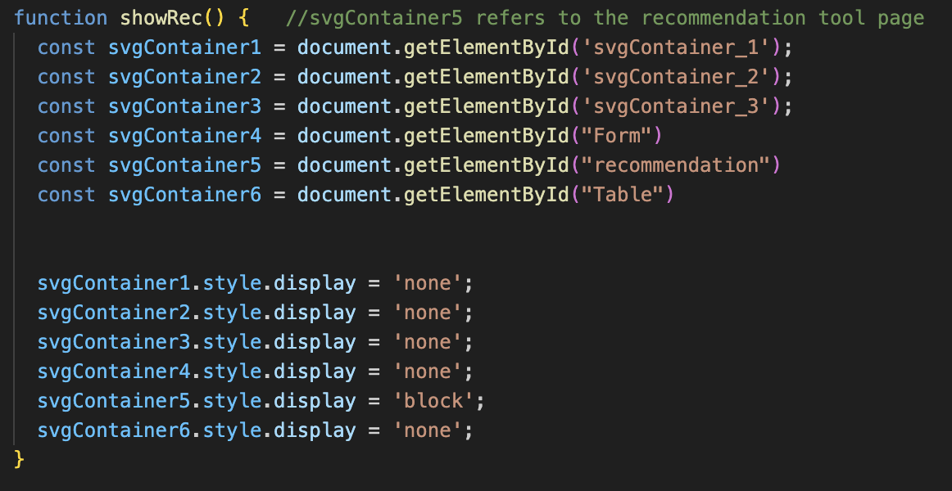

Verify that svgContainer_5 is displayed while others are hidden.

- showTable() function

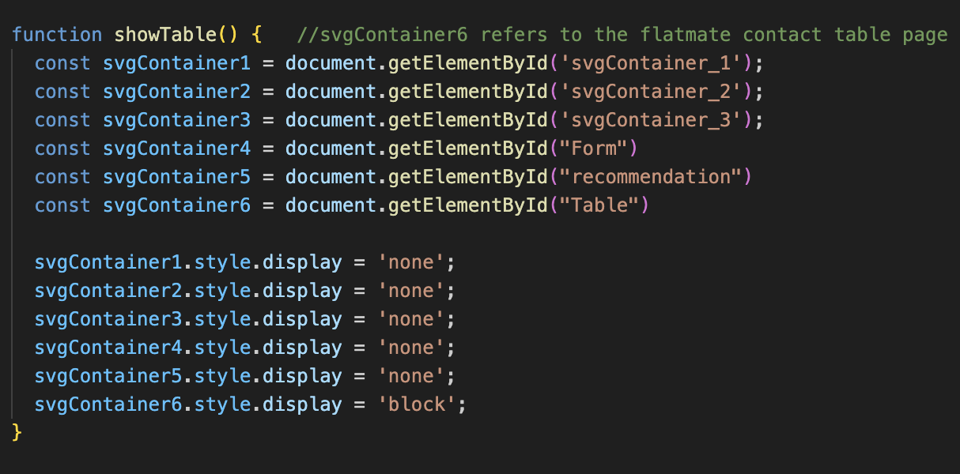

Verify that svgContainer_6 is displayed while others are hidden.

Test Table

Test Case | Expected Outcome | Pass/Fail
Call showHousePrices() function  (Button Clicked) | svgContainer_1 is displayed while other pages are hidden | Pass
Call showHCB() function  (Button Clicked) | svgContainer_2 is displayed while other pages are hidden | Pass
Call showAverageRent() function  (Button Clicked) | svgContainer_3 is displayed while other pages are hidden | Pass
Call showForm() function  (Button Clicked) | svgContainer_4 is displayed while other pages are hidden | Pass
Call showRec() function  (Button Clicked) | svgContainer_5 is displayed while other pages are hidden | Pass
Call showTable() function  (Button Clicked) | svgContainer_6 is displayed while other pages are hidden | Pass

Functional Testing

Objective: validates the software system against functional requirements, test each of the individual functions or features of a completed system.

I invited my friends as tester during the level of functional testing.

Form Submission Test

Input Validation

- Test E-mail format validation (example@domain.com)

- Test that Budget only accepts numeric values.

- Test that Date of Birth only accepts Char values.
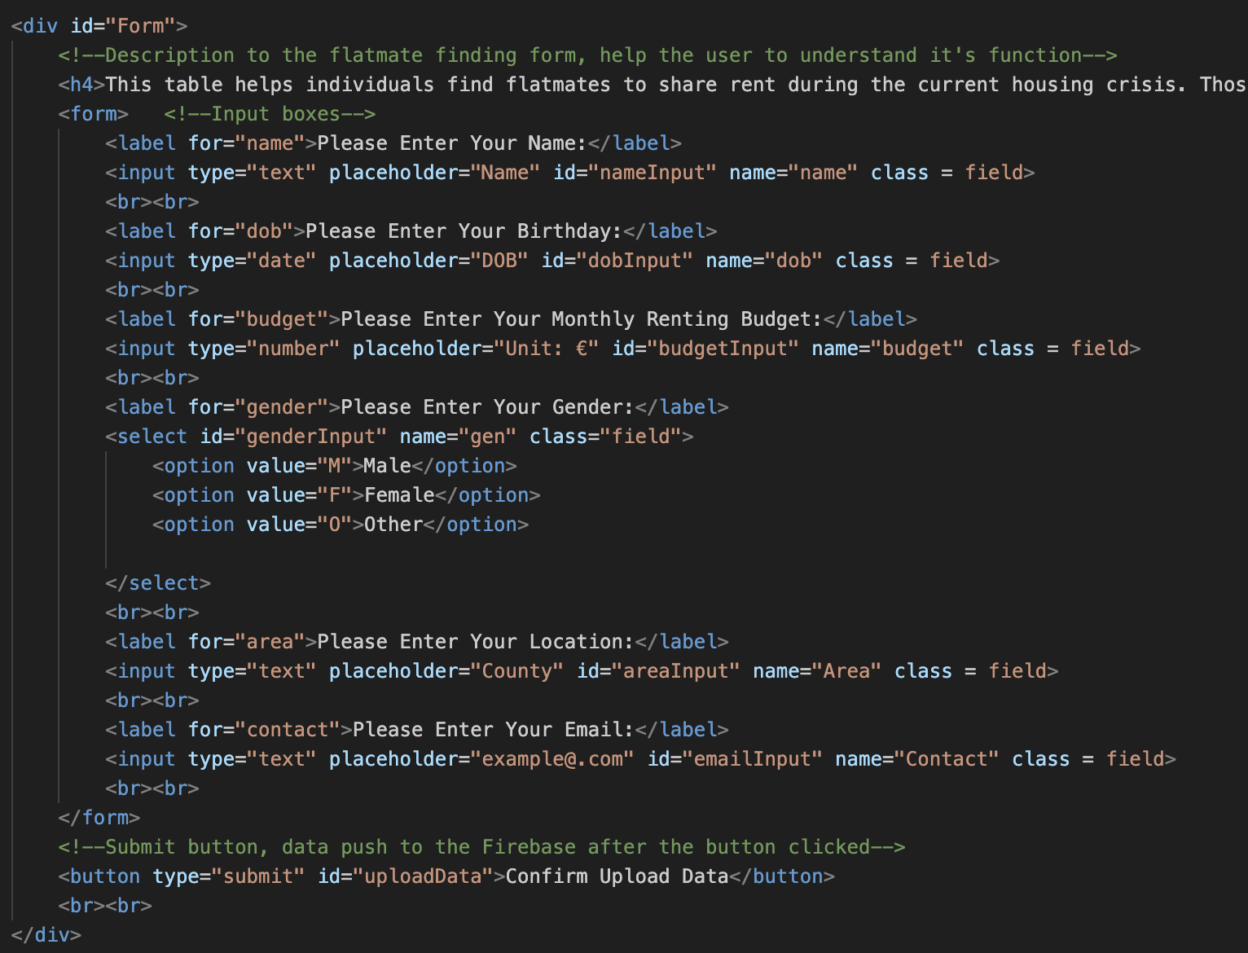
The validation process is completed by hardcoding the input box, so that only certain values can be accepted.

Test Table

Test Case | Expected Outcome | Pass/Fail
E-mail | Accept multiple value types, including str, int, float, etc. | Pass
Birthday | Only Char value can be entered. | Pass
Budget | Only int value can be entered. | Fail  (Float value is accepted)
Gender | Only options in the selection box can be choose. | Pass

Database Submission Test

- An alert box displays a confirmation message if the data is correctly pushed to the Firebase.

- If the alert box doesn't pop out during the uploading process, the user will be aware of the error.

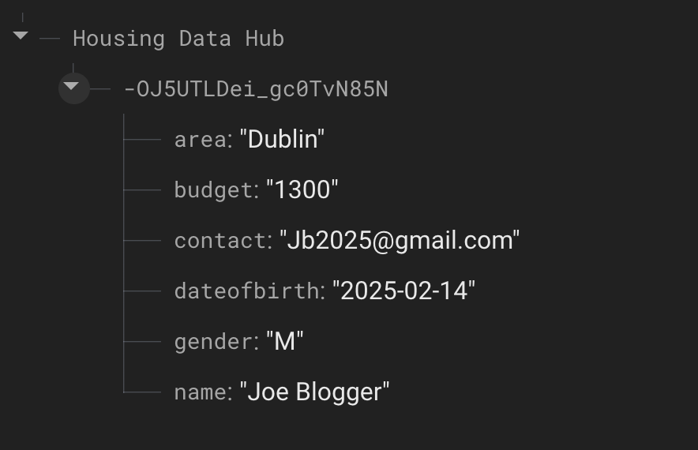

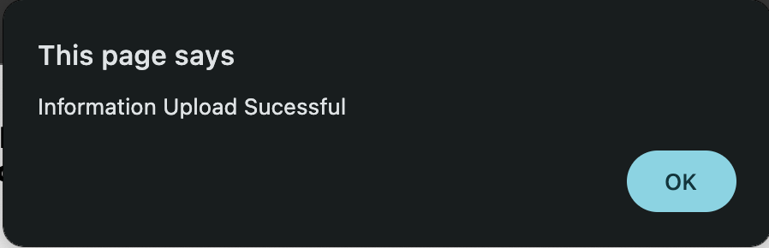

Test Table

Test Case | Expected Outcome | Pass/Fail
Submit Successful | An alert box displays a confirmation message if the data is correctly pushed to Firebase | Pass
Submit Unsuccessful | An alert box displays a confirmation message if the data is correctly pushed to Firebase | Fail  (Confirmation Message shouldn’t be displayed in case of unsuccessful submission)

4. Algorithm

Merge multiple Housing Cost Overburden Data

This algorithm aims to merge HCB data of six years into a cleaned single csv file for further processing. Data has been extracted from six cleaned csv files using with.open() method. Merged new data been written into a new csv file using with.write() method.

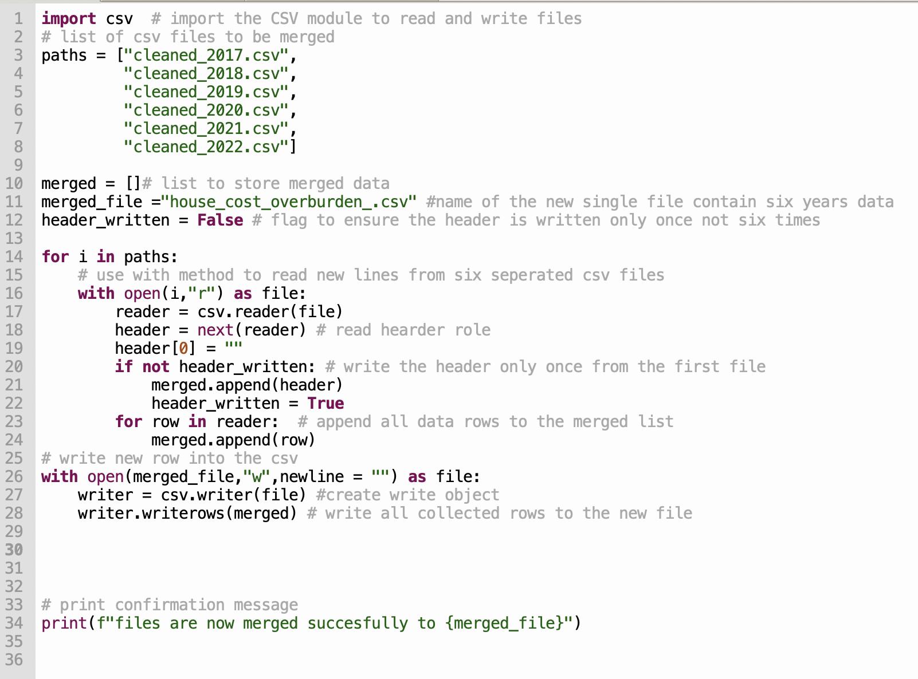

Pseudocode

